Our Key Vocabulary
1 | extinct
2 | recipe
3 | fossils
4 | habitat
5 | rhyme
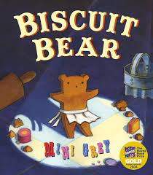
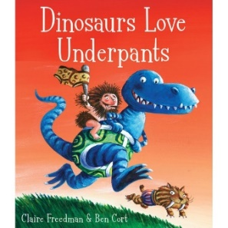
Dinosaurs Love Underpants: Biscuit Bear:
Reading/Physical Development/Writing:
- Labelling
- Descriptive writing
- Recipe writing
- Alternate stories
- Story sentences

Is it better to be big rather than small?
Expressive Art & Design:
- Designing pants
- Creating dinosaur sound-scapes
- Baking/decorating biscuits
- Character painting
- Clay fossil making

Understanding the World:
- Learning about the job of an archaeologist
- Classifying dinosaurs
- Looking at different environments.
- Biscuit science experiment

Number and Numerical Patterns
- Explore numbers to 20
- Spatial reasoning
- Counting patterns and sequences
- More and less
- Shape transformation and rotation

